1. Protists are classified into which domain?
a. Archaea
b. Bacteria
*c. Eukarya
d. Protista
e. Monera

2. Volvox and diatoms are
a. absorptive heterotrophs
b. ingestive heterotrophs
*c. autotrophs

3. Amoeba and Paramecium are
a. absorptive heterotrophs
*b. ingestive heterotrophs
c. autotrophs

4. Which of these heterotrophic protists is not strictly unicellular?
a. Amoeba
b. Paramecium
*c. Physarum
d. Plasmodium

5. Which of these protists is a parasite?
a. Ceratium (dinoflagellate)
b. Fucus
c. Sargassum
d. Stentor
*e. Trypanosoma
f. Volvox

6. Which protist is a strict heterotroph?
a. Ceratium (dinoflagellate)
b. Euglena
c. Sargassum
*d. Trypanosoma
e. Volvox

7. Which protists have chloroplasts?
a. Ceratium (dinoflagellate)
b. Euglena
c. Sargassum
d. Volvox
*e. all of these have chloroplasts
f. none of these have chloroplasts

8. Which of these heterotropic protists is a strict parasite?
a. Amoeba
b. Paramecium
c. Stentor
*d. Plasmodium

9. Which of these autotrophic protists is unicellular?
*a. Ceratium (dinoflagellate)
b. Fucus
c. Sargassum
d. Volvox

10. The diagram below is which protist?
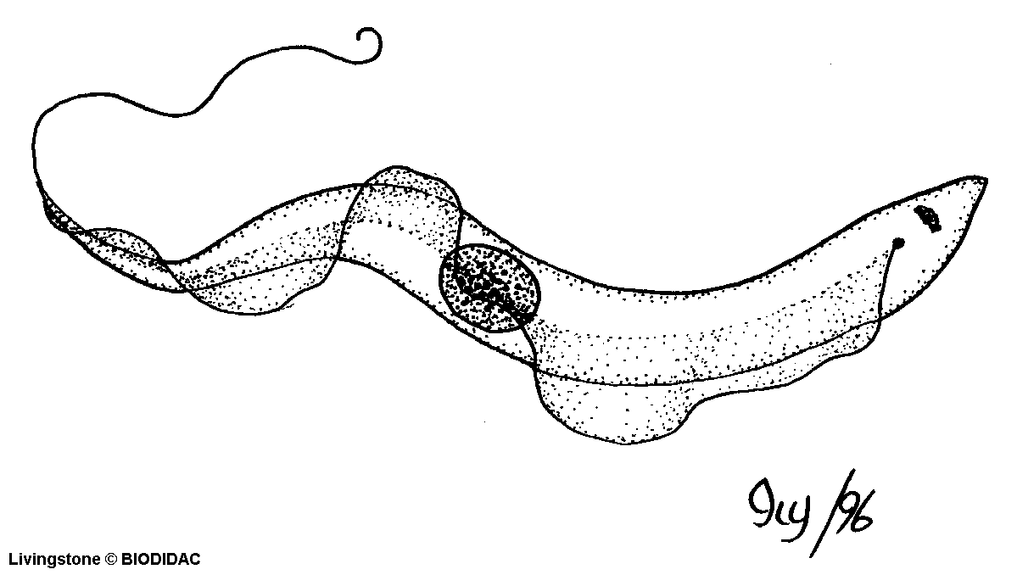

a. diatom
b. Ceratium (dinoflagellate)
c. Euglena
*d. Trypanosoma
e. Volvox

11. The diagram below is which protist?
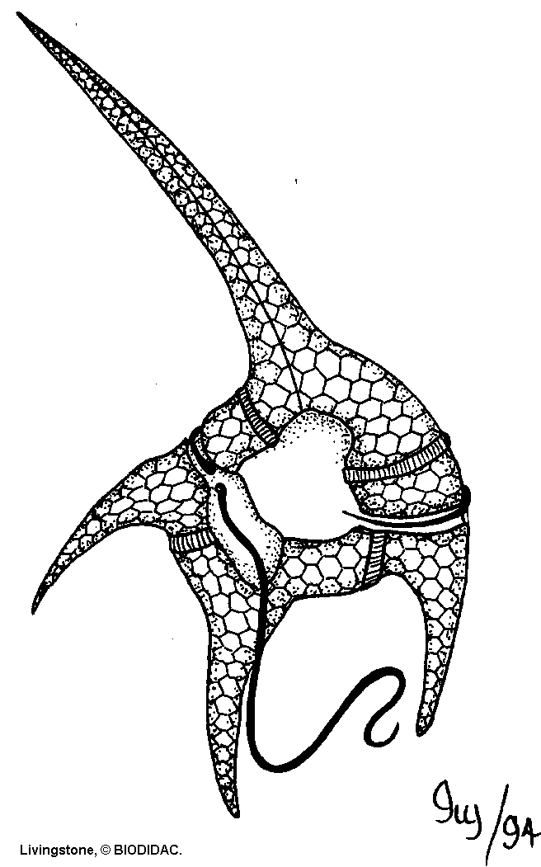

a. diatom
*b. Ceratium (dinoflagellate)
c. Euglena
d. Trypanosoma
e. Volvox

12. The diagram below is which heterotrophic protist?
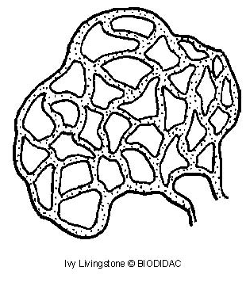

a. Amoeba
b. Paramecium
*c. Physarum
d. Plasmodium

13. The diagram below is which protists?
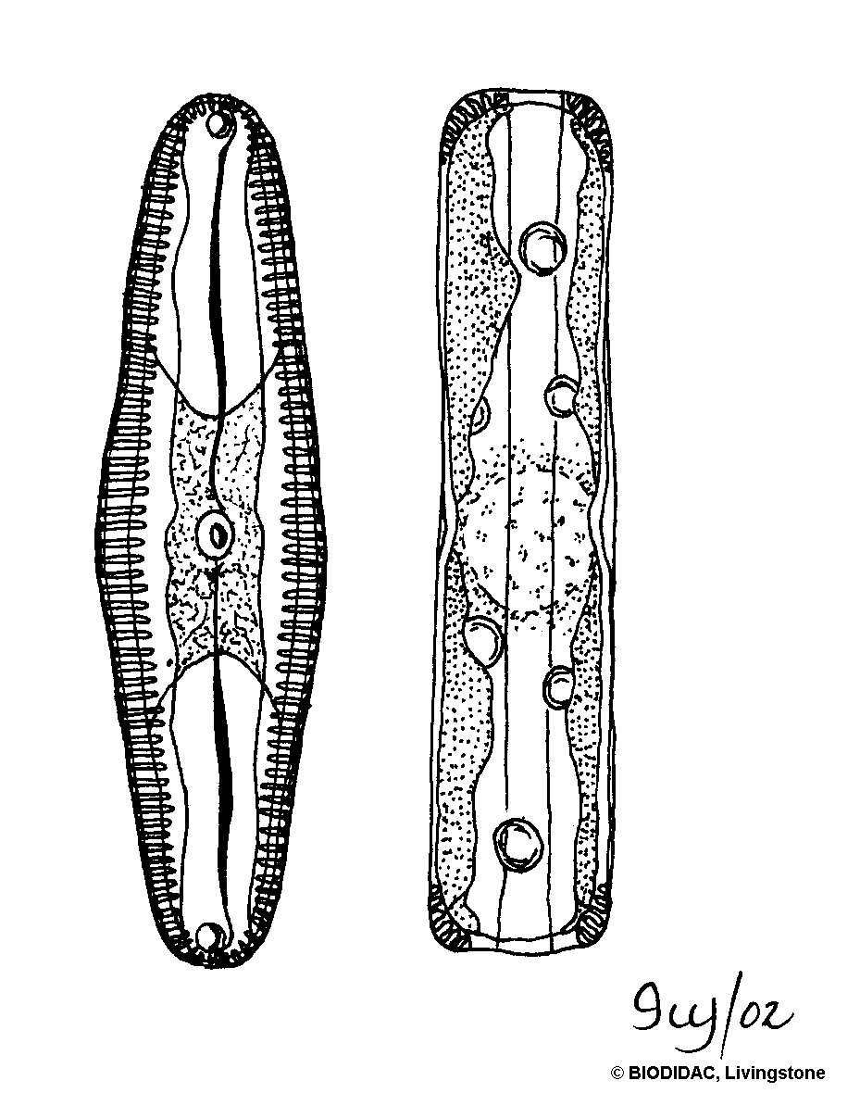

*a. diatoms
b. Ceratium (dinoflagellates)
c. Euglena
d. Trypanosoma
e. Volvox

14. The diagram below is which heterotrophic protist?
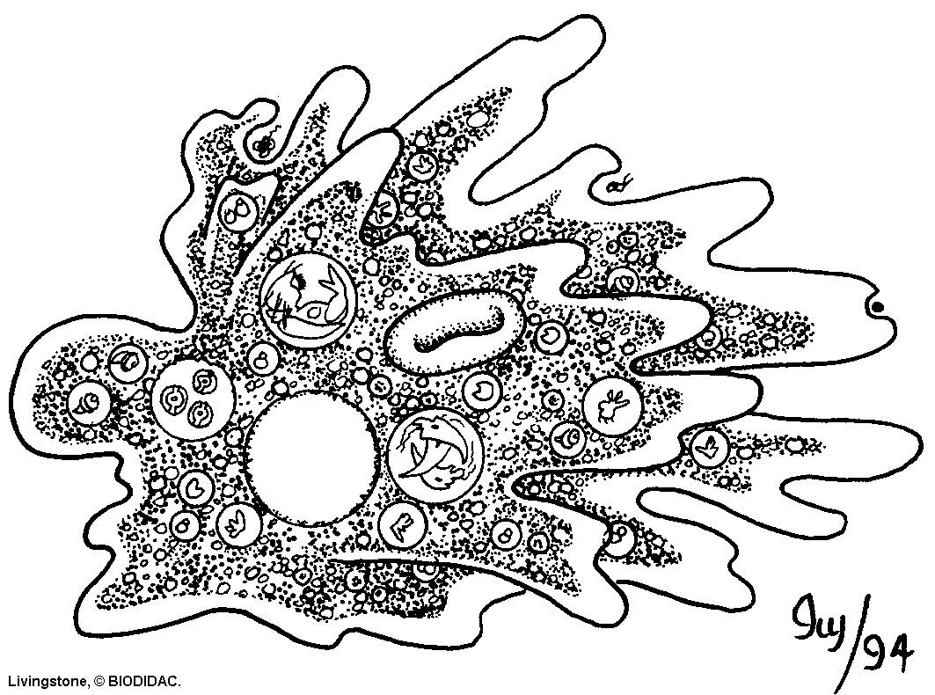

*a. Amoeba
b. Paramecium
c. Physarum
d. Plasmodium

15. The diagram below is which autotrophic protist?
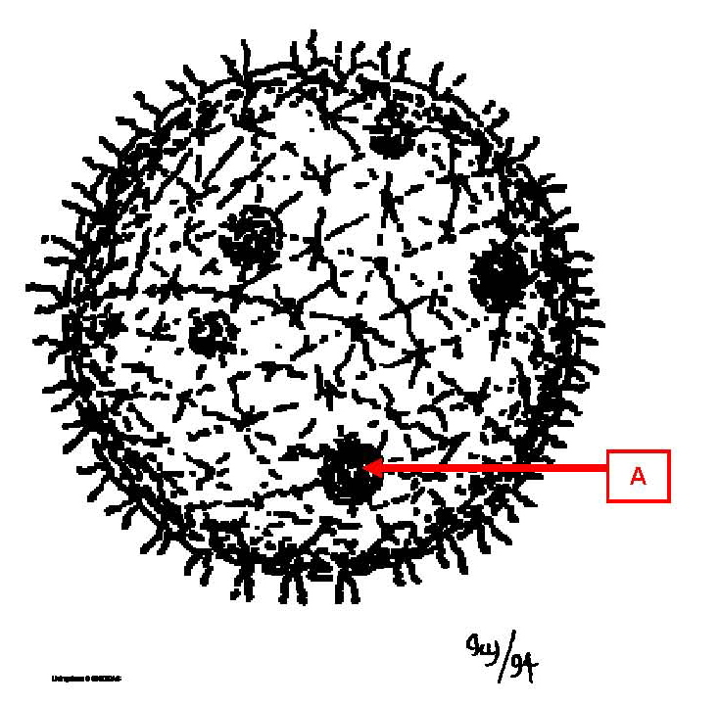

a. diatom
b. Ceratium (dinoflagellate)
c. Euglena
d. Sargassum
*e. Volvox

16. On the diagram below, what is A?

a. contractile vacuole
*b. daughter colony
c. oral groove
d. pseudopodium
e. vegetative cell

17. On the Sargassum diagram below, what is A?
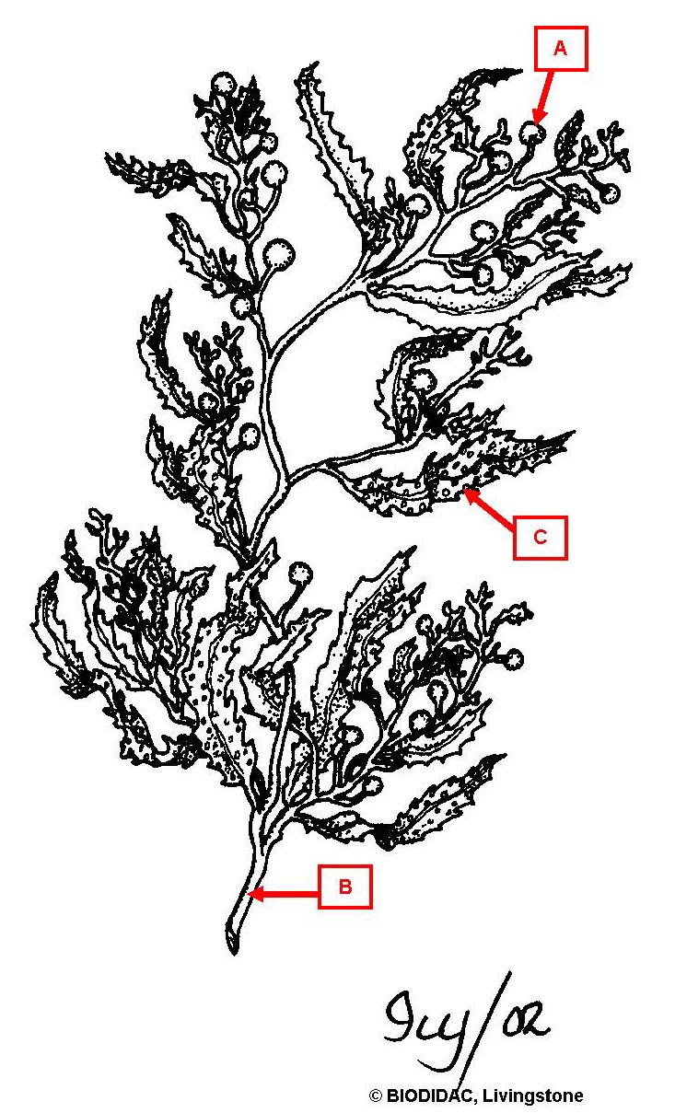

*a. air bladder
b. blade
c. holdfast
d. stipe

18. On the Laminaria diagram below, what is A?
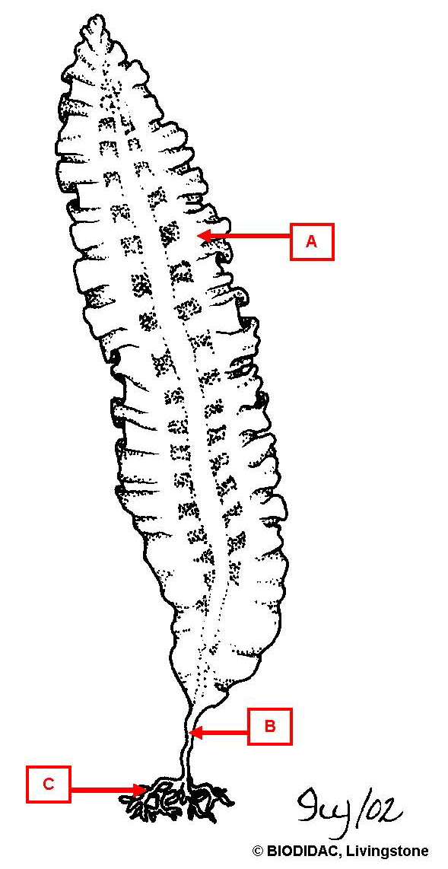

a. air bladder
*b. blade
c. holdfast
d. stipe

19. On the Laminaria diagram below, what is B?

a. air bladder
b. blade
c. holdfast
*d. stipe

20. On the Laminaria diagram below, what is C?

a. air bladder
b. blade
*c. holdfast
d. stipe

21. The diagram below is which heterotrophic protist?
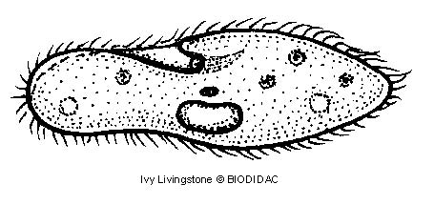

a. Amoeba
*b. Paramecium
c. Physarum
d. Plasmodium

22. The diagram below shows the life cycle for which heterotrophic protist?
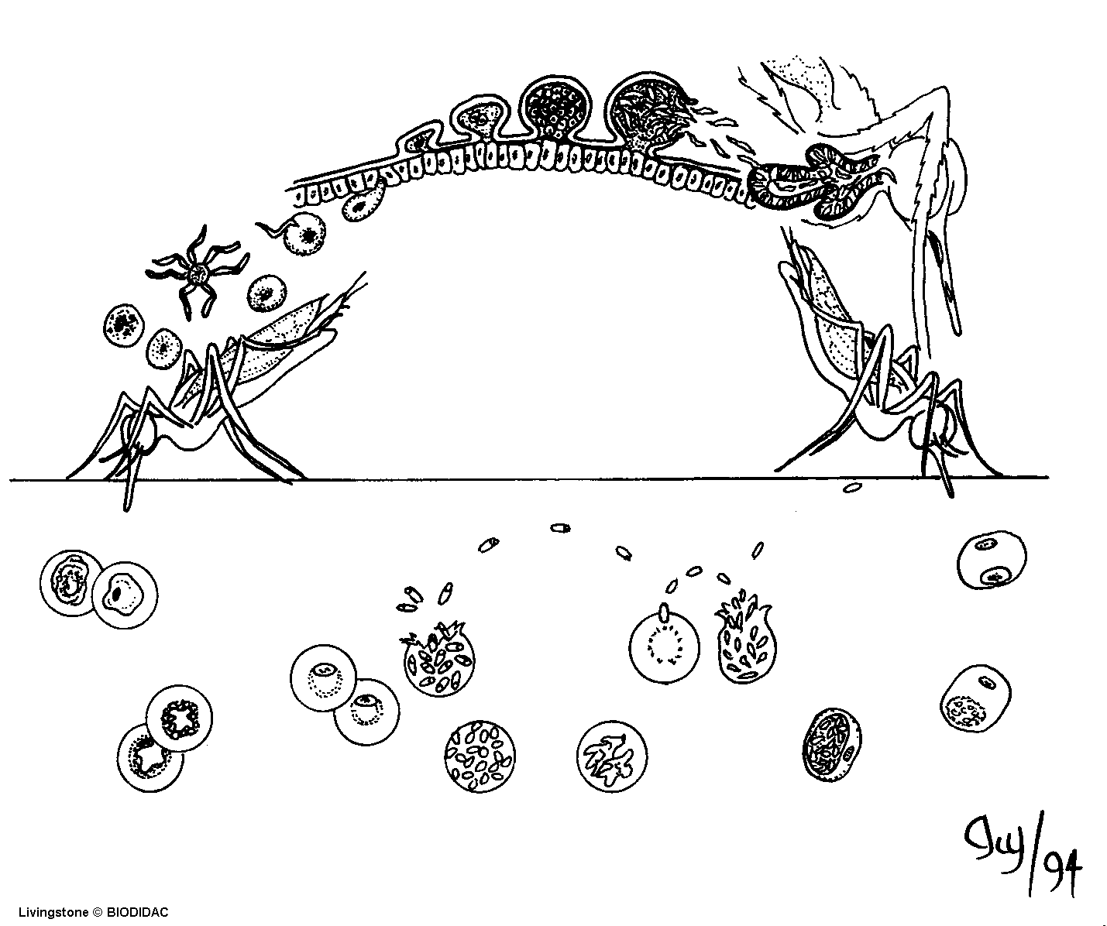

a. Amoeba
b. Paramecium
c. Physarum
*d. Plasmodium
e. Trypanosoma

23. On the Stentor diagram below, what is A?
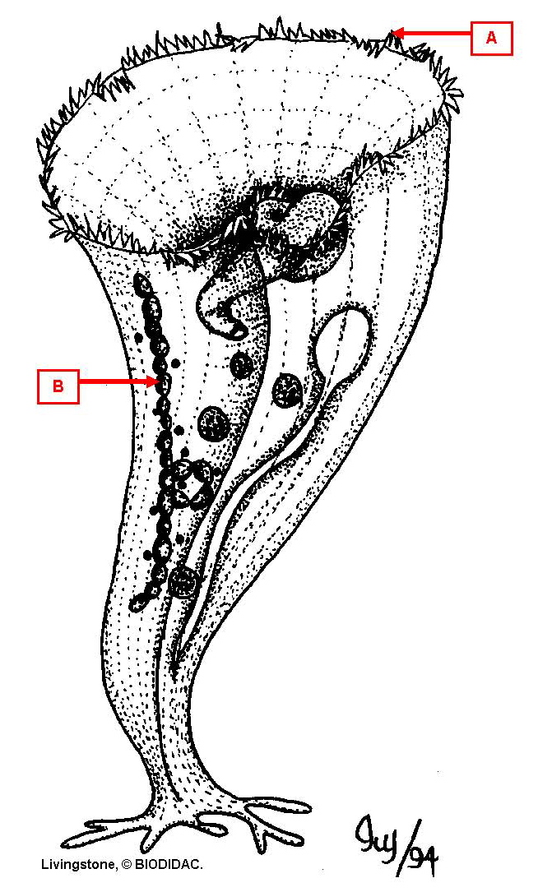

*a. cilia
b. contractile vacuole
c. flagellum
d. macronucleus
e. oral groove
f. pseudopodium

24. On the Stentor diagram below, what is B?

a. cilia
b. contractile vacuole
c. flagellum
*d. macronucleus
e. oral groove
f. pseudopodium

